Student Complaints procedure

Any complaints?
We hope your experience with ICE will be an enjoyable and educational one. If you do have a complaint or any questions, there are a number of things you can do. Firstly, you can speak to your teacher. Teachers do want, like & need feedback. Secondly, if you do not wish to speak to your teacher, you may talk to your Director of Studies (Kerry). Ultimately, if you still feel that your question or complaint hasn’t been resolved, you can speak to Tim Shoben (Director) who will try his very best to help you.
If you have a problem – WE WANT TO HEAR ABOUT IT!

We are sure that you will find all our staff and students to be friendly and welcoming, but if you feel that you have not been treated well, please report this to Tim or Kerry as soon as possible.
You will also have an opportunity to fill in an anonymous questionnaire at any time in which you can say anything you want (you don’t have to use your name). These questionnaires are available on the first staircase on the left in 97 White Lion Street.
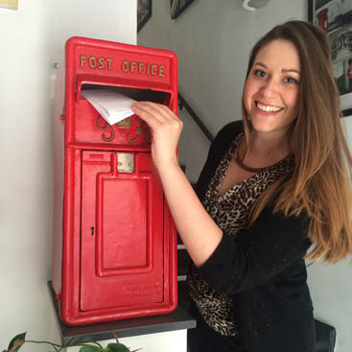

You will additionally be emailed a link to the leaving questionnaire in the final week of your course, so that you can let us know of your overall impression of your time at the school.

Partner/ ETO Complaints Procedure
If you have any issues whatsoever, please talk to Katy on enrol@letslearnenglish.org or +44 (0) 207 278 5553
or Tim Shoben (Director): tim@letslearnenglish.org +44 (0) 207 278 9067
We want to work together successfully and we want to hear about anything that concerns you about our school or our service.

Group Leader Complaints procedure
If you have any problems/issues/complaints about our service, please speak to our Office Manager, Katy on enrol@letslearnenglish.org or +44 (0) 207 278 5553. You can always speak to our Director, Tim on the above details, too.

What will Happen?
We will...
- Listen to your complaint carefully
- Investigate your complaint if appropriate
- Carry out agreed action as quickly as possible
- Respect confidentiality unless we suspect UK law has been broken or if the matter
concerns someone under 18 years of age
- Act in accordance with our Safeguarding Policy if the matter concerns someone under 18
years of age
- Keep written records of all conversations and actions taken
- Check you are happy with the result

Unresolved Complaints
If you are not happy with the result of your complaint or the way we have dealt with it:
- Talk to the Director of Studies or talk to the Director.
- If you are still not happy, you or your parents can write to our professional association, English UK:

English UK, 47 Brunswick Court, Tanner Street, London, SE1 3LH
Tel: +44 20 7608 7960
Fax: +44 20 7608 7961
Email: reception@englishuk.com

